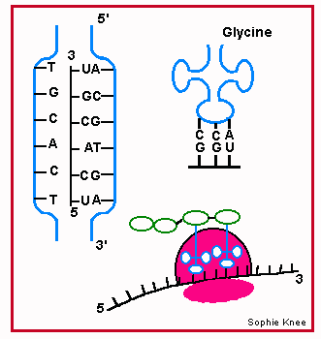

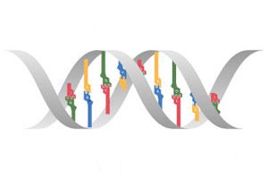

C | T | A | C | A | T | G | C | G | A | T | G | T | G | A | T | T | G | A | A

