10 Prepare Office Memorandum

Objectives
• Compose a Memorandum for the medical assistant staff.
• Compose professional communication.

Overview
Using today’s date, compose an email Memorandum to inform the entire office staff that the refrigerator will be cleaned on Friday and that any items left in the refrigerator when the office closes will be disposed of.

Competencies
• Compose professional correspondence utilizing electronic technology, CAAHEP V.P-8, ABHES 7-g, 7-h
• Perform basic keyboarding skills by locating the keys on a keyboard, ABHES 7-h
• Utilize an EMR, CAAHEP VI.P-6, ABHES 7-b
Estimated completion time: 20 minutes

Measurable Steps
1. Click on the Correspondence icon (Figure 2-28).
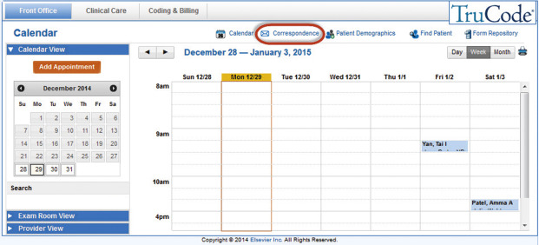
FIGURE 2-28 Correspondence icon.
2. Select the Memorandum template from the Emails section of the left Info Panel.
3. In the body of the email, document “All staff” in the To field.
4. Document your name in the From field.
5. Document the current date in the Date field.
6. Document “Refrigerator Cleaning” in the Subject field.
7. Compose a professional business letter notifying the staff of the refrigerator cleaning in the message field.
8. Click the Send button. A confirmation message will appear.
9. Within the Sent Memorandums tab, select the saved memorandum (Figure 2-29).
54
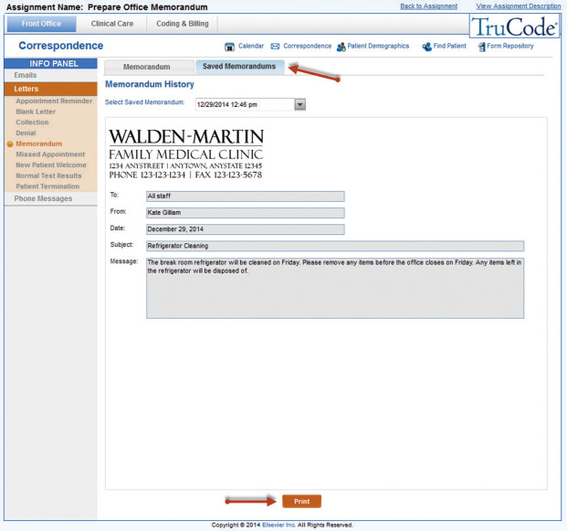
FIGURE 2-29 Saved Memorandums.
10. Click the Print button if instructed to print.
Now use the Back to Assignment link to complete the Post-Case Quiz found on the Info Panel for this assignment!

