7 Complete Incident Report for Celia Tapia

Objectives
• Search for a patient record.
• Access office forms.
• Complete an Incident Report for a patient-related incident.
• Access a saved Incident Report.

Overview
Celia Tapia experiences issues with repeated urinary tract infections. She is in the office today to provide a clean catch urine specimen. Around 10:30 am, after providing the specimen and while washing her hands, she spilled water on the floor and slipped. Dr. Martin and the Medical Assistant assisted Ms. Tapia back to her exam room. The medical staff has been notified, and it was decided that an absorbent mat should be placed in front of the sink so that this doesn’t happen again. Dr. Martin determined that Ms. Tapia developed minor bruising. Complete an Incident Report for this accident.

Competencies
• Complete an incident report related to an error in patient care, CAAHEP X.P-7, ABHES 7-a
• Define the principles of standard precautions, CAAHEP III.C-5, ABHES 8-a
• Demonstrate the principles of self-boundaries, CAAHEP V.A-2, ABHES 10-b
• Describe the process in compliance reporting incident reports, CAAHEP X.C-11d, ABHES 4-e
• Identify safety signs, symbols, and labels, CAAHEP XII.C-1, ABHES 4-e
• Perform compliance reporting based on public health statutes, CAAHEP X.P-5, ABHES 4-b
• Perform risk management procedures, ABHES 4-e
Estimated completion time: 40 minutes

Measurable Steps
1. Click on the Form Repository icon (Figure 2-19).
45
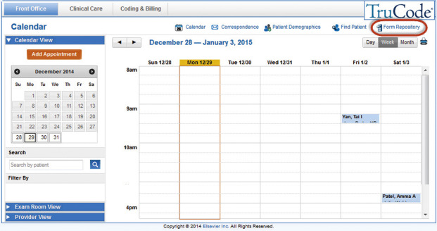
FIGURE 2-19 Form Repository icon.
2. Select Incident Report from the Office Forms section of the left Info Panel (Figure 2-20).
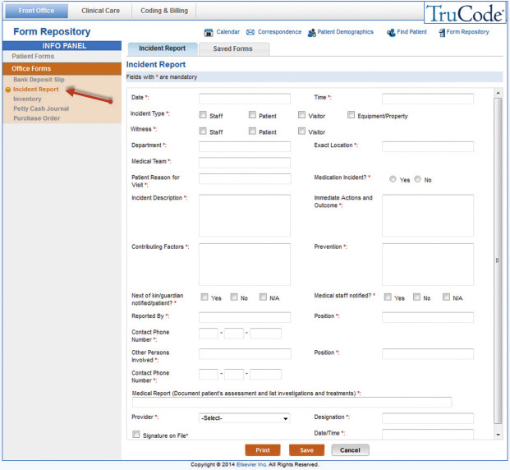
FIGURE 2-20 Incident Report form.
3. Document the date and time in the date and time fields.
4. Select the Patient checkbox for the Incident Type.
5. Select the Patient checkbox for the Witness.
6. Document “Urology” as the Department.
7. Document “Bathroom” as the Exact Location.
8. Document “physician, medical assistant” as the Medical Team.
9. Document “collection of the specimen” as the Patient Reason for Visit.
10. Select the No radio button to indicate that the incident is not a Medication Incident.
11. Document “Patient slipped and fell because of water spilled on the floor after washing her hands.” in the Incident Description field.
12. Document “Physician and medical assistant assisted patient to exam room. Physician determined that there was minor bruising from the fall.” in the Immediate Actions and Outcome field.
13. Document “Spilled water on the floor.” in the Contributing Factors field.
14. Document “Place absorbent mat in front of the sink.” in the Prevention field.
15. Select the No checkbox to indicate that the next of kin/guardian has not been notified.
16. Select the Yes checkbox to indicate that the medical staff has been notified.
17. Document your name in the Reported By field.
18. Document “medical assistant” in the Position field.
19. Document “123-123-1234” in the Contact Phone Number field.
20. Document “Dr. Martin” in the Other Persons Involved.
21. Document “physician” in the Position field.
46
22. Document “123-123-1234” in the Contact Phone Number field.
23. Document “Minor bruising, no treatment” in the Medical Report field.
24. Select James A. Martin, MD from the Provider dropdown.
25. Document “Self-inflicted, accidental” in the Designation field.
26. Select the Signature on File checkbox and document the date and time in the Date/Time field.
27. Click the Save button.
28. Within the Saved Forms tab, select the Incident Report from the dropdown menu (Figure 2-21).
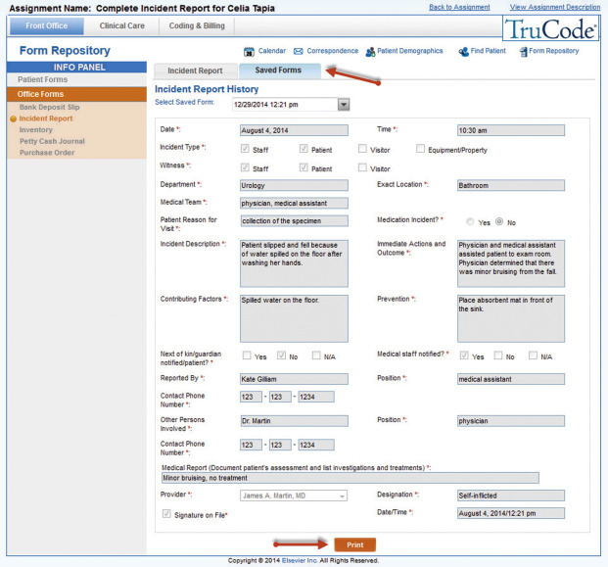
FIGURE 2-21 The Incident Report from the dropdown menu of the Saved Forms tab.
29. Click the Print button to print the saved Incident Report.
Now use the Back to Assignment link to complete the Post-Case Quiz found on the Info Panel for this assignment!

