8 Complete Incident Report for Employee

Objectives
• Access office forms.
• Complete an incident report for an employee-related incident.
• Access a saved incident report.

Overview
Around 9:30 am, an employee dropped a bottle of bleach in the laboratory while preparing a 1:10 bleach solution used as a disinfectant, causing it to splash in their face and eyes. After a 15-minute eyewash and basic first aid, Dr. Walden assessed the employee and determined that no additional treatments were needed. The medical staff has been notified. Additional training on the best way to handle chemical bottles will be reviewed with the staff. Complete an incident report for this accident.

Competencies
• Complete an incident report related to an error in patient care, CAAHEP X.P-7, ABHES 4-a
• Demonstrate the proper use of eyewash equipment, CAAHEP XII.P-2a, ABHES 8-g
• Describe basic principles of first aid as they pertain to the ambulatory healthcare setting, CAAHEP I.C-14, ABHES 8-g
• Describe the process in compliance reporting incident reports, CAAHEP X.C-11d, ABHES 4-e
• Perform compliance reporting based on public health statutes, CAAHEP X.P-5, ABHES 4-b
• Recognize and respond to medical office emergencies, ABHES 8-g
• Recognize the physical and emotional effects on persons involved in an emergency situation, CAAHEP XII.A-1, ABHES 10-b
Estimated completion time: 35 minutes

Measurable Steps
1. Click on the Form Repository icon (Figure 2-22).
48
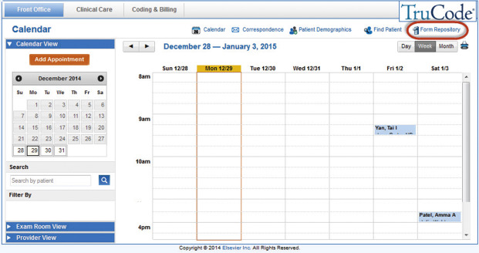
FIGURE 2-22 Form Repository icon.
2. Select Incident Report from the Office Forms section of the left Info Panel (Figure 2-23).
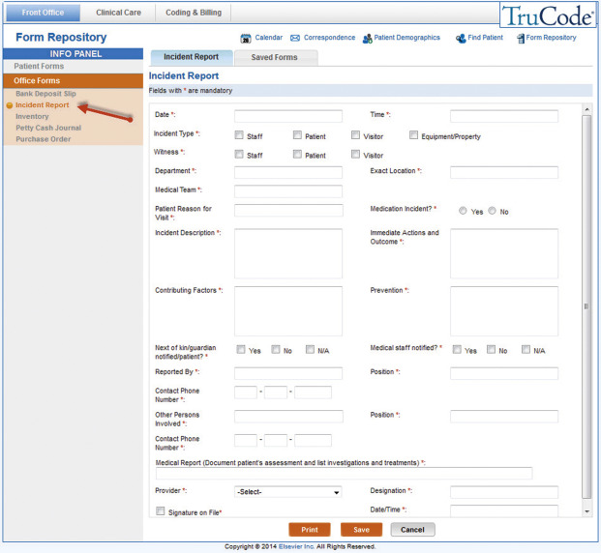
FIGURE 2-23 Incident Report form.
3. Document the data and time in the Date and Time fields.
4. Select Staff for the Incident Type.
5. Select Staff for the Witness.
6. Document “Laboratory” as the Department and exact location.
7. Document “physician, medical assistant” as the Medical Team.
8. Document “N/A” as the Patient Reason for Visit.
9. Select the No radio button to indicate that the incident is not a Medication Incident.
10. Document “Employee dropped bottle of bleach causing the bleach to splash into their face and eyes.” in the Incident Description field.
11. Document “Employee was assisted at the eyewash station and the eyes were flushed with water for 15 minutes.” in the Immediate Actions and Outcome field.
12. Document “N/A” in the Contributing Factors field.
13. Document “Employee training on the best way to handle chemical bottles.” in the Prevention field.
14. Select the No checkbox to indicate that the next of kin/guardian has not been notified.
15. Select the Yes checkbox to indicate that the medical staff has been notified.
16. Document your name in the Reported By field.
17. Document “medical assistant” in the Position field.
18. Document “123-123-1234” in the Contact Phone Number field.
19. Document “none” in the Other Persons Involved field.
20. Document “N/A” in the Position field.
49
21. Document “000-000-0000” in the Contact Phone Number field.
22. Document “No additional treatment needed.” in the Medical Report field.
23. Select Julie Walden, MD from the Provider dropdown.
24. Document “Self-inflicted, accidental” in the Designation field.
25. Select the Signature on File checkbox.
26. Document the date and time in the Date/Time field and click the Save button.
27. Within the Saved Forms tab, select the Incident Report from the dropdown menu (Figure 2-24).
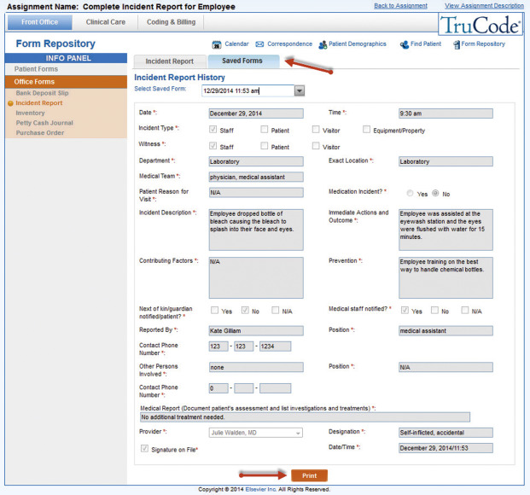
FIGURE 2-24 The Incident Report from the dropdown menu of the Saved Forms tab.
28. Click the Print button to print the saved Incident Report.
Now use the Back to Assignment link to complete the Post-Case Quiz found on the Info Panel for this assignment!

