The following activity can be used as
a classifying activity.

The first four pages are the KEY.
If you wanted to, you could cut them apart,
place them in a baggie
and have the students group them.

The next four pages have just the definitions.

You can use the pages after that to cut apart and have the students glue next to
the correct definitions.

The last page is a blank grid.

Adapted from Dan Mulligan’s Sort Cards - http://www.simplyachieve.com/resources.html
bar graph | used to display  categorical (discrete) data  ~  used to compare a small sample | 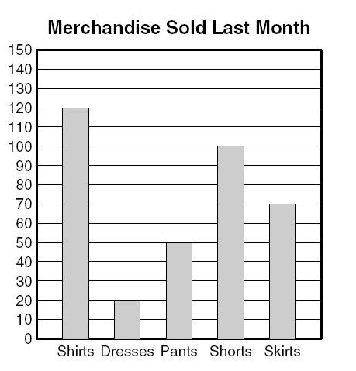
line graph | used to display continuous data  ~  used to display changes over  a period of time | 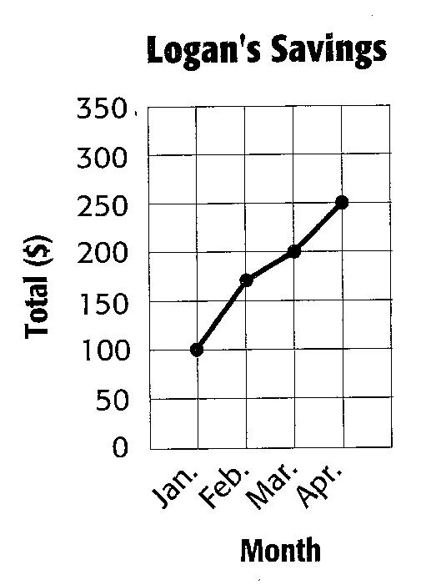
scale | this part of a graph  must be listed with  equal distances  ~  it helps label the graph | 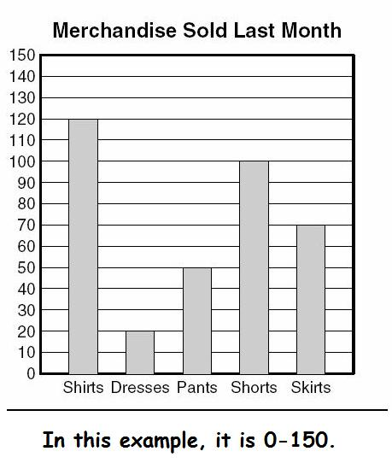
interval | the distance between  one number and the next  on the scale of a graph  ~  it is how the numbers are grouped  and they must be equal | 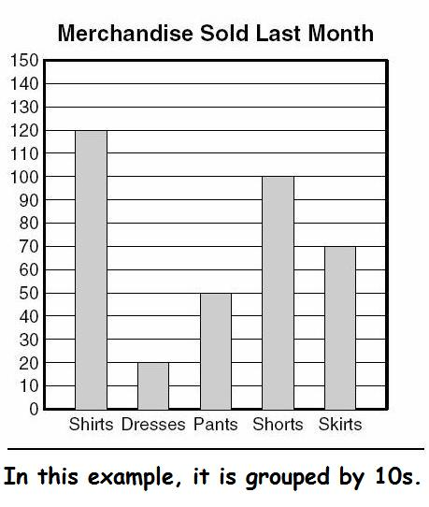
circle graph | a type of display  used to show a relationship  of the parts to a whole | 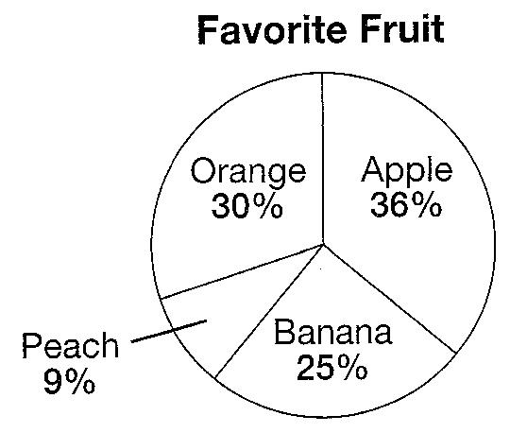
stem-and-leaf plot | a type of display  used to show  an ordered set of data  ~  shows the frequency of data and can be used  to find the range, the median, and the mode | 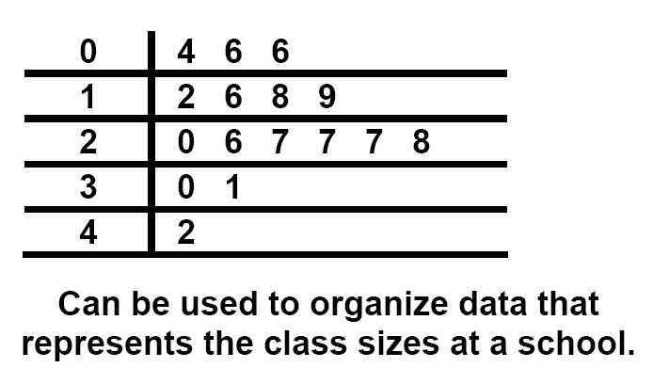
box-and-whisker plot | a type of display  used to show the distribution  of a set of data  ~  show how the data clusters  around the middle (median) | 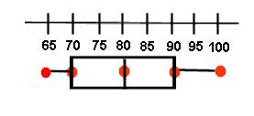
mean | the numerical average  of the data set  ~  add the numbers in the data set together  and divide the sum  by the number of data pieces in the set  ~  works well for sets of data  with no very high or low numbers | 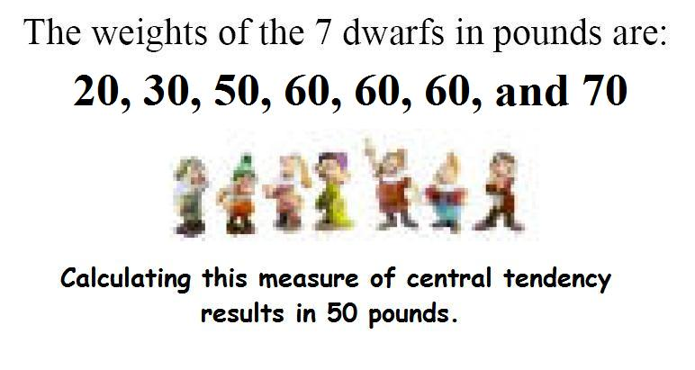
median | the middle point  of a data set  in ranked order  ~  a good choice to use when data sets  have a couple of points much higher or lower  than most of the others | 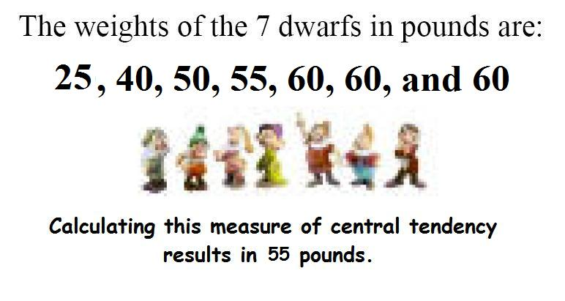
mode | the piece of data  that occurs most frequently  in a set of data  ~  a good descriptor to use when the set of data  has many identical data points | 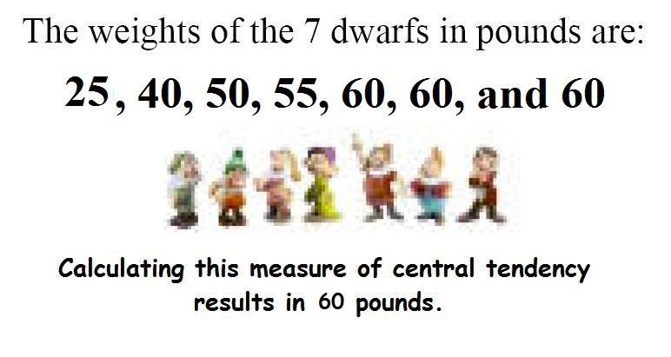
lower extreme | the lowest number  in a set of data | 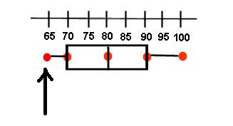
upper extreme | the highest number  in a set of data | 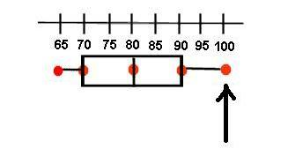
range | the difference between  the greatest and least values in a set of data | 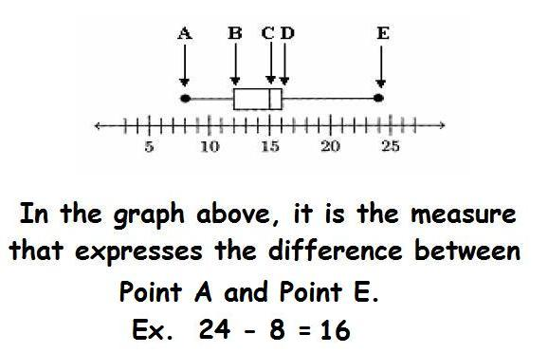
lower quartile | the median of  the lowest extreme  and the median | 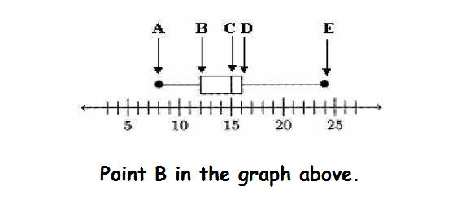
upper quartile | the median of  the median and  the highest extreme | 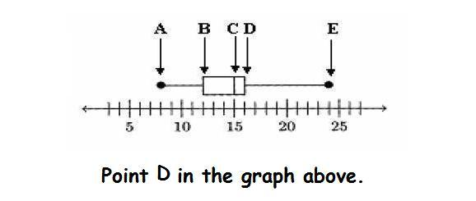
inter-quartile range | the difference between  the upper quartile  and the lower quartile | 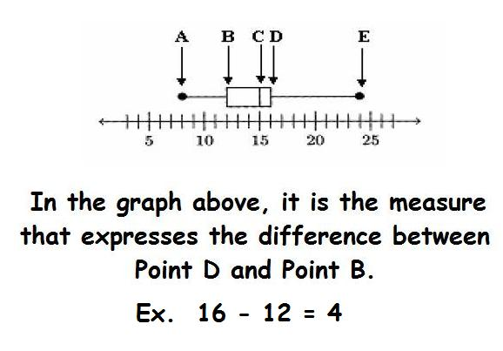

used to display
categorical (discrete) data
~
used to compare a small sample
used to display continuous data
~
used to display changes over
a period of time
this part of a graph
must be listed with
equal distances
~
it helps label the graph
the distance between
one number and the next
on the scale of a graph
~
it is how the numbers are grouped
and they must be equal
a type of display
used to show a relationship
of the parts to a whole
a type of display
used to show
an ordered set of data
~
shows the frequency of data and can be used
to find the range, the median, and the mode
a type of display
used to show the distribution
of a set of data
~
show how the data clusters
around the middle (median)
the numerical average
of the data set
~
add the numbers in the data set together
and divide the sum
by the number of data pieces in the set
~
works well for sets of data
with no very high or low numbers
the middle point
of a data set
in ranked order
~
a good choice to use when data sets
have a couple of points much higher or lower
than most of the others
the piece of data
that occurs most frequently
in a set of data
~
a good descriptor to use when the set of data
has many identical data points
the lowest number
in a set of data
the highest number
in a set of data
the difference between
the greatest and least values in a set of data
the median of
the lowest extreme
and the median
the median of
the median and
the highest extreme
the difference between
the upper quartile
and the lower quartile

Cut these apart  and glue them  in the appropriate place on the definition page | bar graph | box-and-whisker plot
circle graph | inter-quartile range | interval
line graph | lower extreme | lower quartile
mean | median | mode
range | upper extreme | upper quartile
scale | stem-and-leaf plot

