DIRECTIONS FOR EXTRA CREDIT

1. Save these questions to your computer.

2. Print out the questions and answer them while watching the movie, Cinderella Man starring Russell Crowe.

3. Type the answers into the questions that you saved to your computer.

4. Using the “Send e-mail to Coach White” button on the website, attach the questions and answers, and email them to Coach White.

Name
Class period

EXTRA CREDIT QUESTIONS FOR CINDERELLA MAN
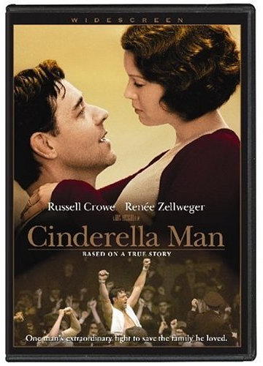

Cast of Characters:
James J. Braddock (aka “Jim”, “Jimmy”, the Bulldog)-Russell Crowe
May Braddock-Jim’s wife-Renee Zelwegger
Joe Gould-Jim’s manager

1. When was the date of the opening fight? (Tuffy Griffith v. James J. Braddock)

2. Which country was the origin of Jim’s background?

3. How would you describe Jim’s life in 1928?

<September 25, 1933 Four years into the Great Depression>

4. How would you describe Jim’s life in 1933?

5. How many men did the foreman need at the docks?

6. What did Jay steal from the butcher shop?

7. Why did Mary Johnson have to live with his uncle in Delaware?

8. What promise did Jim make to his son Jay?

9. How did Braddock break his hand?

10. Why did the commissioner (Mr. Johnson) revoke Braddock’s fight license?

11. What did Jim’s friend Mike do for a living before the stock market crash?

12. How much did Jim and his wife need to turn the electricity back on?

13. Where did Jim’s wife take the children?

14. Jim went to two places to get money. One was the relief office, what was the other?

15. What news did Joe bring to Jim?

16. Why didn’t Jim have his own equipment for the Corn Griffin fight?

17. Who won the fight between Griffin and Braddock?

18. Describe Joe’s apartment.

19. How did Joe convince the commissioner (Mr. Johnson) to allow Jim to fight again?

20. Who won the John Henry Lewis v. Braddock fight?

21. Who won the Lasky v. Braddock fight?

22. What images flashed through Jim’s head in the ring that drove him to succeed?

23. What did Jim do at the relief office that was so surprising?

24. Where was Mike spending nights?

25. What happened to Mike?

26. What happened to 2 of Max Baer’s opponents?

27. How would YOU describe Max Baer?

28. Why were so many people at the church?

29. To many people watching and listening to the fight, what did Jim Braddock represent?

30. Who won the Baer v. Braddock fight?

31. Where did Jim have a house that he and his wife lived in for the rest of their lives?

32. Find 3 things in Chapter 14 (and include the page numbers) that were in the movie? EXPLAIN your answers

33. Find 3 things in Chapter 15 (and include the page numbers) that were in the movie? EXPLAIN your answers

